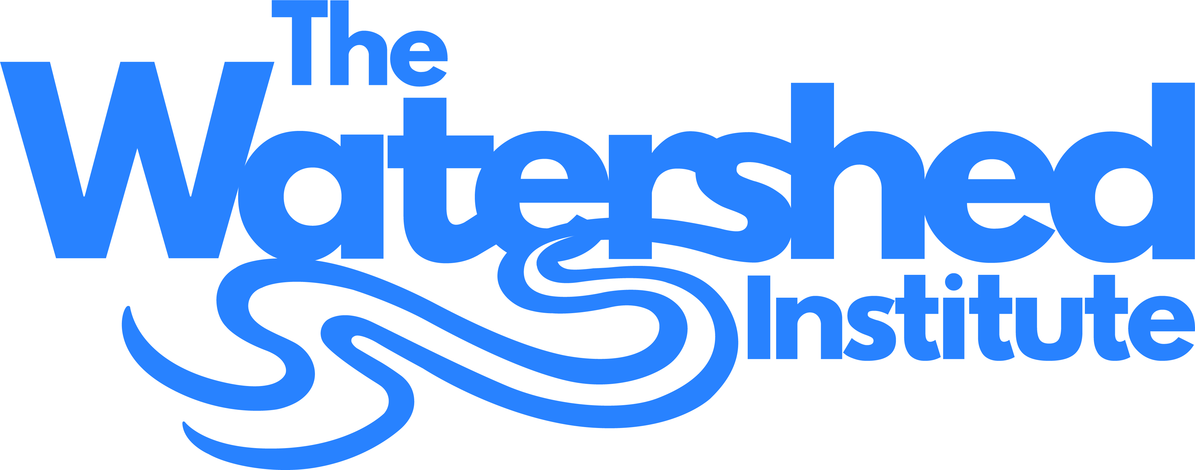
Full Time Position Available

Watershed Educator

The Watershed Institute is seeking an enthusiastic and motivated person with strong knowledge about water and watersheds for its award-winning environmental education program, located in the LEED- Platinum Watershed Center, on the 950-acre Watershed Reserve in Hopewell Township, New Jersey. Education staff conducts approximately 400 programs annually, reaching 10,000 people. Among these environmental science and ecology-based programs are school field trips addressing the Next Generation Science Standards, children’s and family programs for the public, teacher workshops, and a summer environmental education day camp. Position begins January 2020; salary range $28,000 to $33,000.

Responsibilities:
- Develop and deliver a range of education programs for schools and the general public.
- Assist in expanding programming to advance equity and inclusion in the outdoors, so that all young people can foster a meaningful, life-long connection with nature.
- Assist with the care and maintenance of educational displays, including live reptiles, fish and insects.
- Engage visitors at the Watershed Center and offsite events, addressing inquiries about the natural world, water quality and the environment; and promoting the Institute’s mission, programs, and activities.
- Develop, secure and maintain equipment and materials for education programs.
- Assist in mentorship and supervision of interns and volunteers;
- Assist staff on occasional facility maintenance, office tasks, and other projects as necessary for the smooth operation of the facility.

General Qualifications:
- Minimum Bachelor’s degree in environmental education, education, the life sciences or related majors, or equivalent life experience
- Experience working with children in an outdoor, educational setting
- Strong interest and enthusiasm for the environment and desire to share it with others,
especially children
- Knowledge of water, watersheds, and natural history
- Experience working with volunteers and/or interns
- Experience designing environmental education programs
- Good organizational skills; ability to multitask
- Excellent communication skills; written, verbal and listening
- Strong spirit of cooperation and teamwork

Interested people should forward a cover letter, resume, and two letters of recommendation to:

Tammy Love, Education Manager
Watershed Institute
31 Titus Mill Road
Pennington, NJ 08534
tlove@thewatershed.org

For more information about the Watershed Association, visit www.thewatershed.org

